A van Leer 1974 limiter guarantees no new maximum/ minimum formed, and it could be formulated as follows for coding:

(I found this material in the article by J.S. Saltzman)

1- Second order flux limiter:

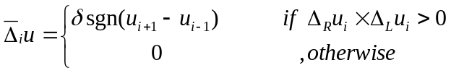
Where:
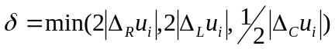
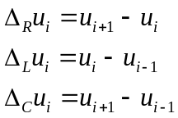
And the limited flux will be:
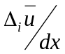

2- Fourth order flux limiter:

Where:
Note: 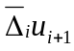 and 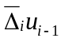 are the u which are already 2nd order flux limiter applied on them
And the limited flux will be:

(I think we are not able to implement 4th order flux limiter without facing many problem, because we need four steps around)

